**Content**

**Common features from the dashboard**

**Owner Product Delivery section**

* my requests list
* request market quote
* request private quote
* requests detail status received quote
* request detail status pending quote
* requests detail cancel and exp. quote
* my requests detail status (accept quote)
* quotes list
* quote detail status pending
* quotes shipping status detail
* my shipping list
* shipping detail status pending
* shipping status shipping completed
* invoice list
* invoice pending status detail
* invoice paid status detail
* archived list
* archived detail
* Admin under ‘owner product delivery’

**Admin section**

* Request
* request pending detail
* request approve detail
* request Get Quotes Detail
* request shipping company detail
* shipping
* shipping detail status pending
* shipping detail status shipping completed
* message
* invoice
* invoice pending pay
* invoice paid
* archive
* archived detail complete project

**Agent Shipping Company**

* employment of staff by enabling sending of email for resume submission
* part consisting of email, website, website create quote & admin.

**Common dashboard features:**

The **dashboard** has some features in common for **Owner Product Delivery, Admin & Agent Shipping Company** sections, such as the tabs named Requests, Company’s Profile, Quotes, Shipping, Message, Invoice, & Archived. The company logo, notification icon, settings along with Administrator option.

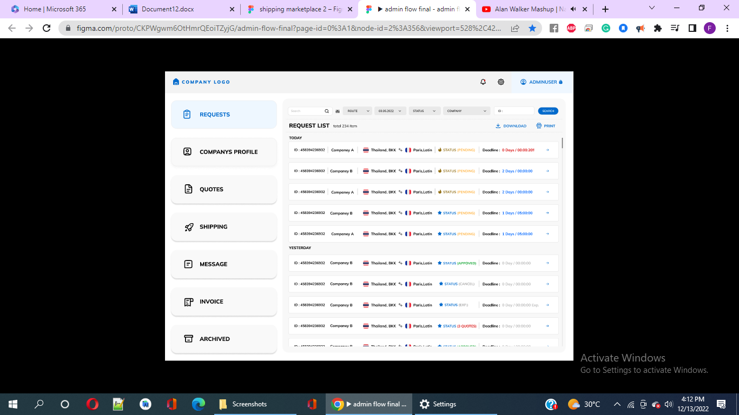

**Figure 1: Common features from the dashboard**

**Owner Product Delivery**

The website is created to keep a record of export of cargo from Thailand to various international countries. This section consists of pages, i.e., my requests list, requests detail status received quote, request private quote, request market quote, request detail status pending quote, requests detail status pending quote, requests detail cancel and exp. quote, my requests detail status (accept quote), quotes list, quote detail status pending, quotes list, quote detail status pending, quotes shopping status detail, my shipping list, shipping detail status pending, shipping status shipping completed. There’s also the Admin in the section where it communicates with the client & message notification is shown as well. There is invoice list, invoice pending status detail, invoice paid status detail, archived list and archived detail.

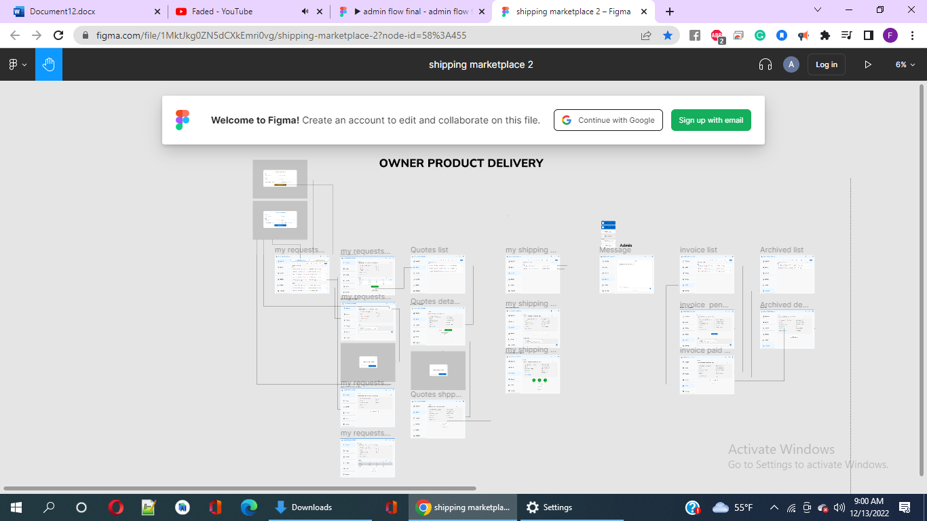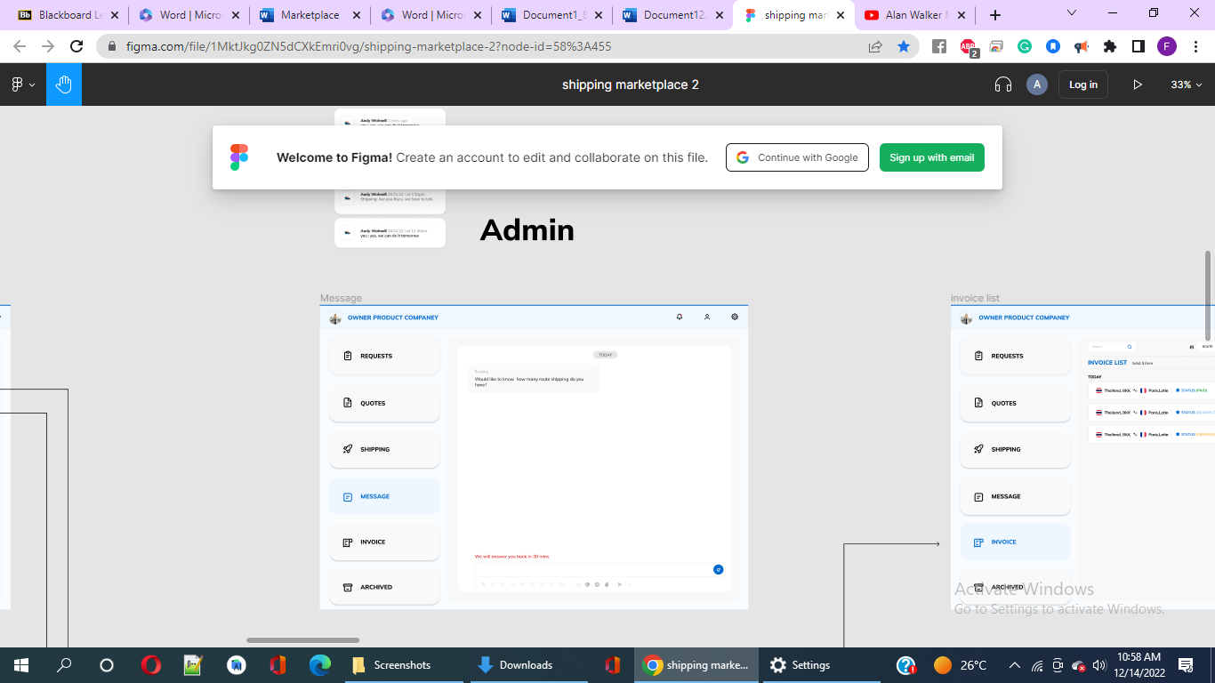

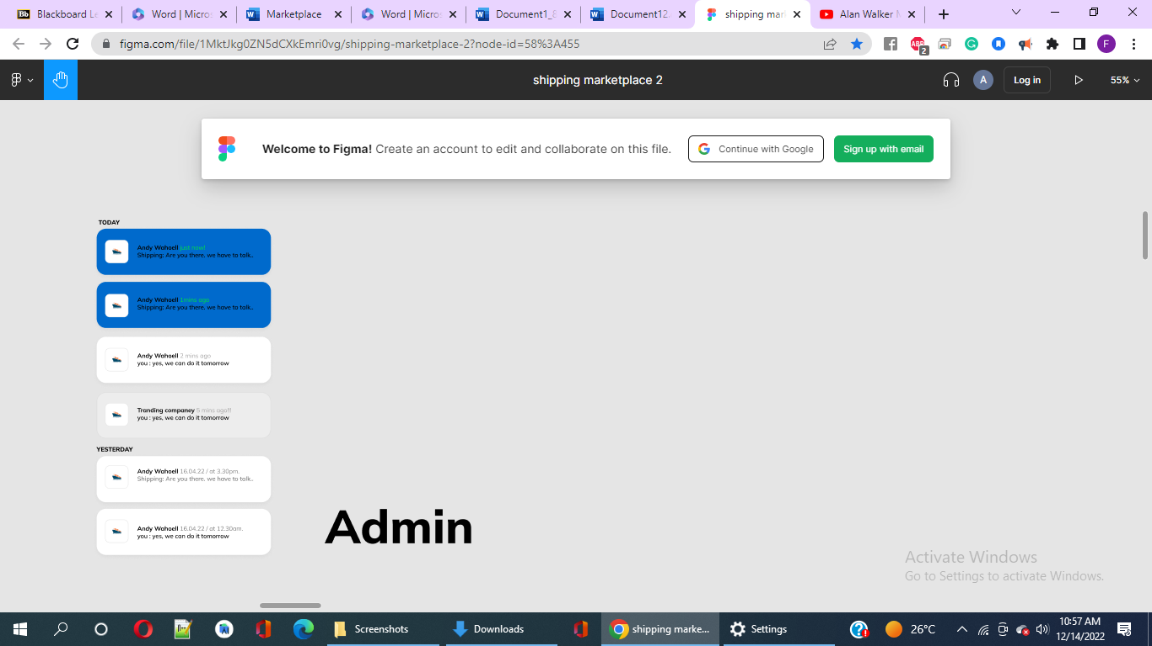

**Figure 2: Owner Product Delivery Section**

**My Requests list**

This tab provides detail of the list of companies that are eligible & confirmed for exporting cargos from Thailand to foreign countries as showed in the following figure. Here, we can see that the search tab, route options, date/time options, status, company and its ID search tab. The Requests List consists of the date for which the details of eligible company's export from Thailand have been provided. The detail for every company’s export includes ID of the company, company names, the initial country from where the export begins to the destination country followed by the reversible arrow between the initial & later country. Status is provided for every country that includes the option such as pending (written in yellow colour), approved (green), cancel(grey), EXP (grey). & Quotes(red) along with serial no. The last is the deadline for every cargo export depending on the contract of every cargo export. When deadline is very near, it appears in red colour as a reminder, otherwise it’s blue in colour. There are tabs for Request Market Quote & Request Private Quote. Finally, there’s a download option and a print button.

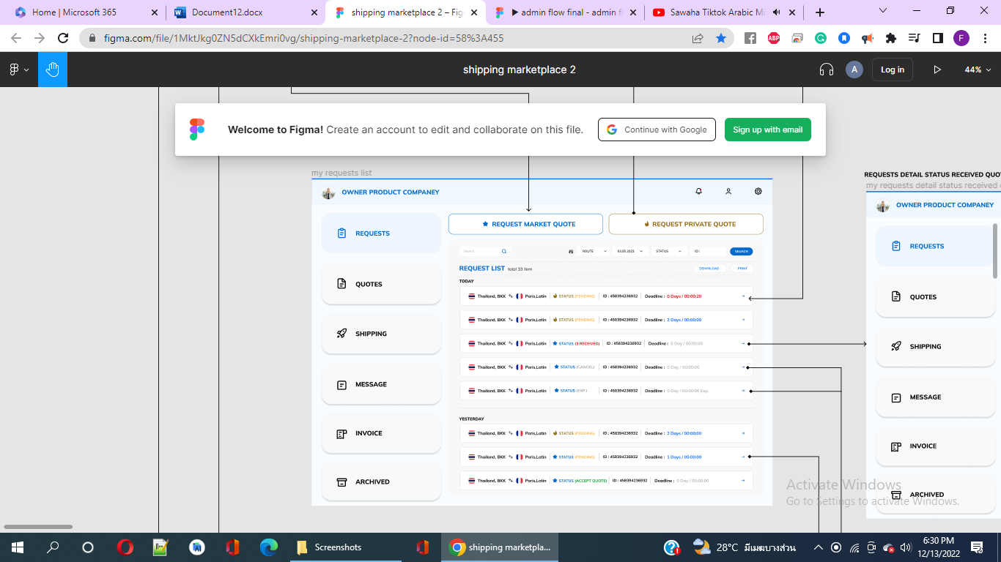

**Figure 3: My request list page**

When we click the option named ‘**request market quote’**, we get the following form and requires filling up the details as shown in the picture below.

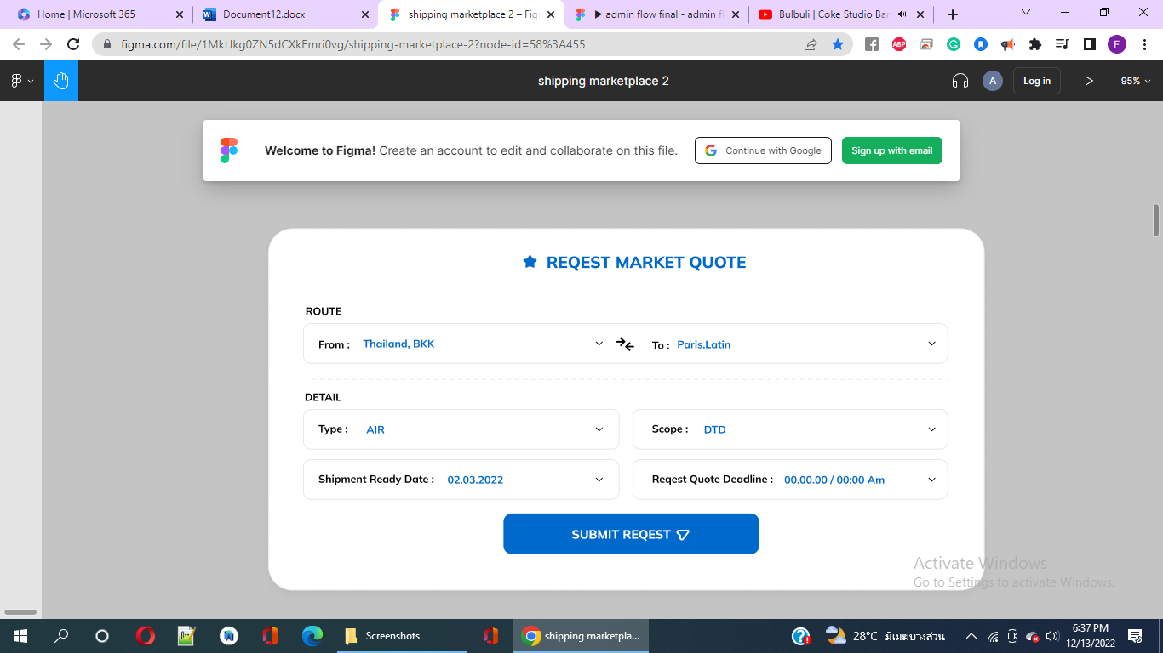

**Figure 4:** R**equest Market Quote page**

When we click the option named ‘**request private quote’**, we get the following form and requires filling up the details as shown in the picture below.

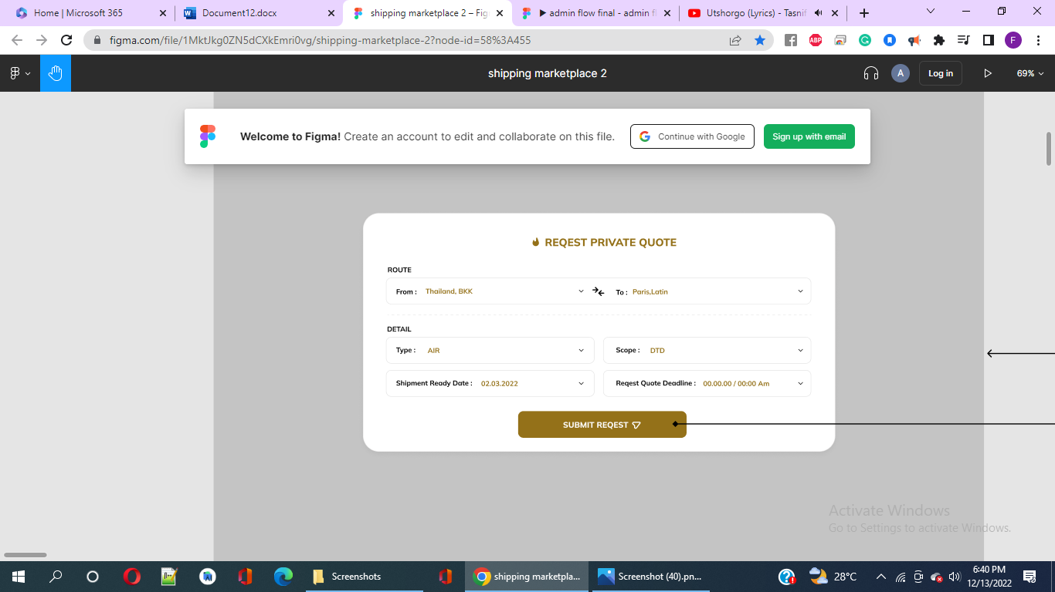

**Figure 5: ‘REQUEST PRIVATE QUOTE’ page**

When users click on **request detail status received quote** for a cargo, the following information regarding the cargo is shown as an example. There are two options such as Accept and Open chat at the end. There’s a cancel button at the top of the page as showed in fig 6.

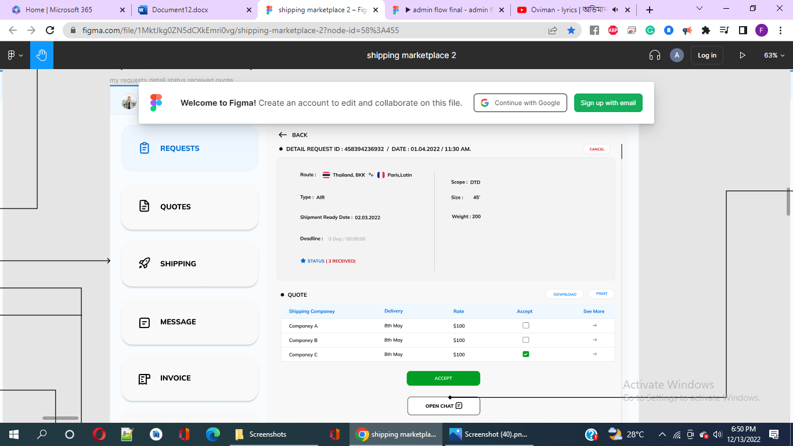

**Figure 6:** **request detail status received quote**

Figure 7 shows ‘**Request Detail Status Pending Quote**’ page as users click on a cargo company tab from ‘**My request list**’ of fig 3. When the users click the cancel button, they are given a popped up a notification asking users if they would like to cancel the request as showed in figure 8. If users click the Yes button, they would be re-directed to the ‘**requests detail status cancel and exp. Quote page**’. Otherwise, no change when they click the cancel button.

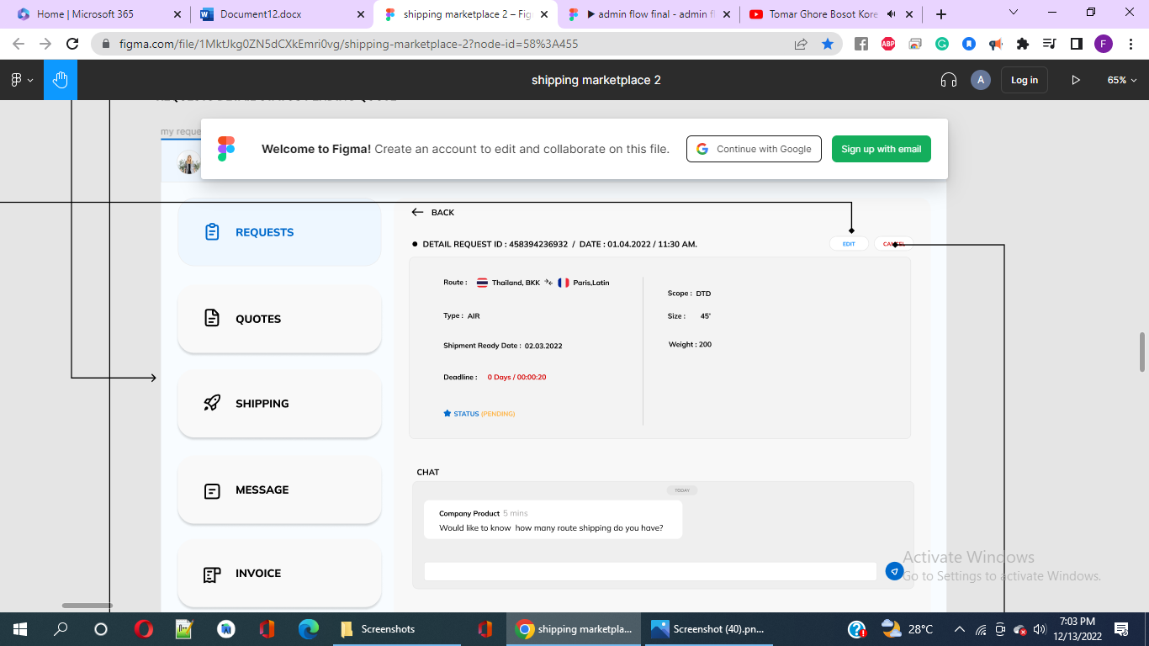

**Fig 7: Request Detail Status Pending Quote**

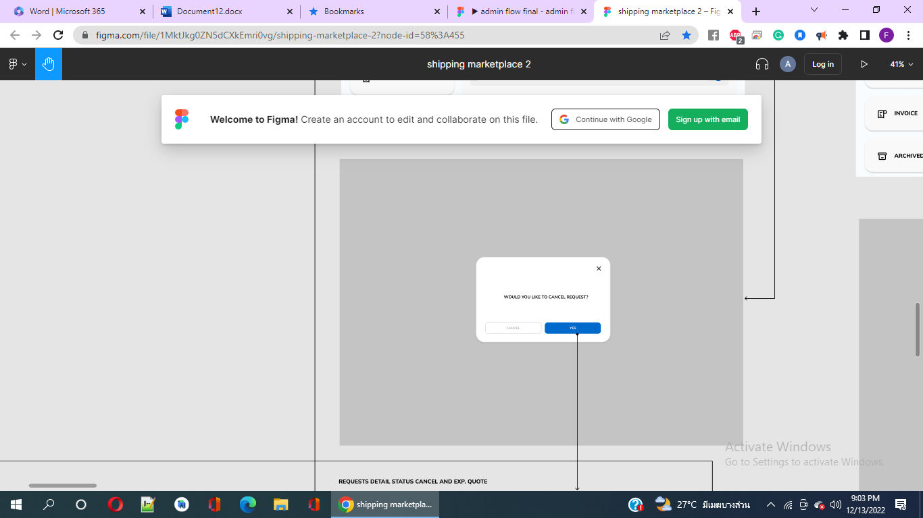

**Fig-8 : notification asking users if they would like to cancel the request**

When users click on **requests detail status cancel and exp. quote** for a cargo, the following information regarding the cargo is shown as an example in figure 9. There is also a view chat option for communication between the company product and the client. When the resend option is clicked by the user, page equivalent to figure 4 that represents filling up **Request Market Quote form**.

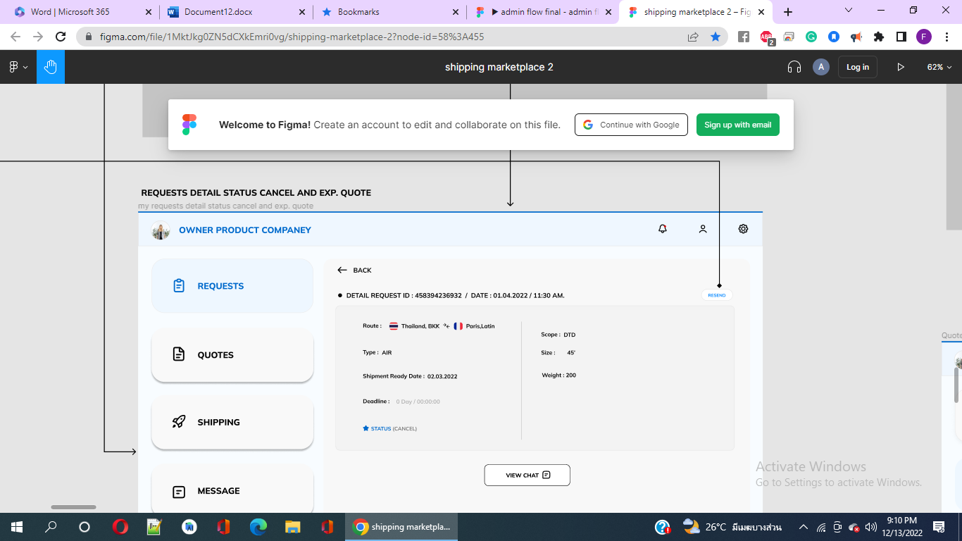

**Figure 9: requests detail status cancel and exp. quote page**

There’s **request** **detail status accept quote** option for cargo. When it’s clicked, the following information & options show up.

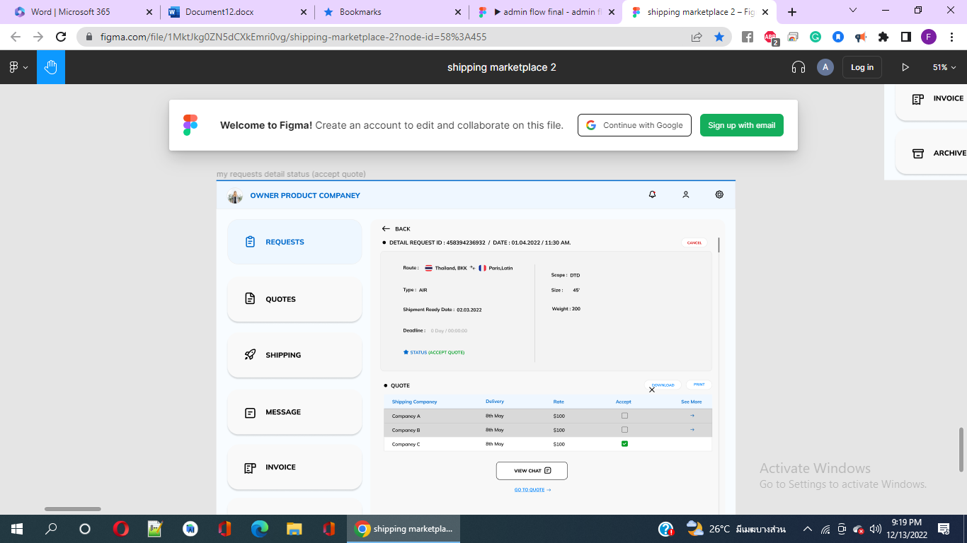

**Figure 10:** **request** **detail status accept quote page.**

**Quotes List**

This lists the confirmed cargo that are yet to be delivered and has status such as CANCELLED, SUBMIN & PENDING. When the first cargo in the list shown below is clicked, ‘**quote detail status pending page**’ is shown in the figure 12 providing such details and options as showed in the figure. When the users click on submit, ‘**Quotes shipping status detail**’ appears equivalent to figure 13. Otherwise, a notification appears asking user if they would like to cancel quote after they clicked cancel as shown in figure 14.

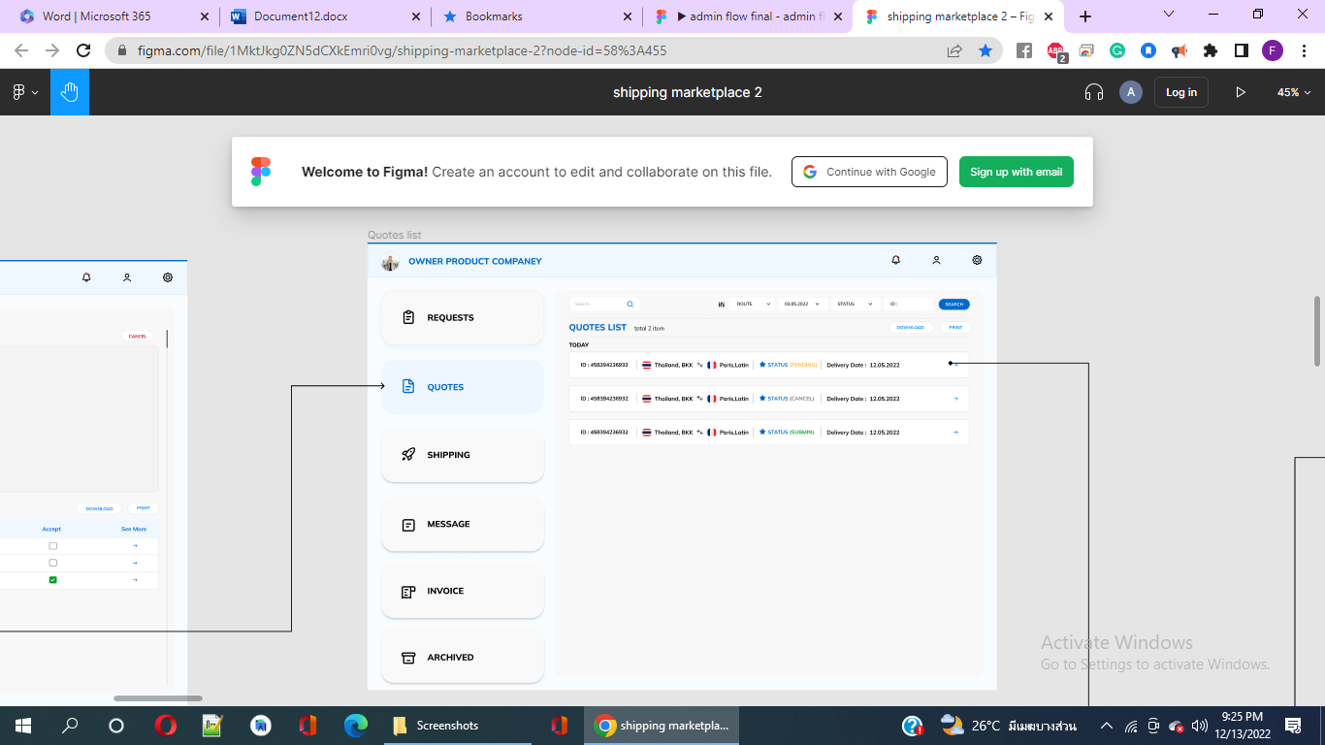

**Figure 11: Quotes list page**

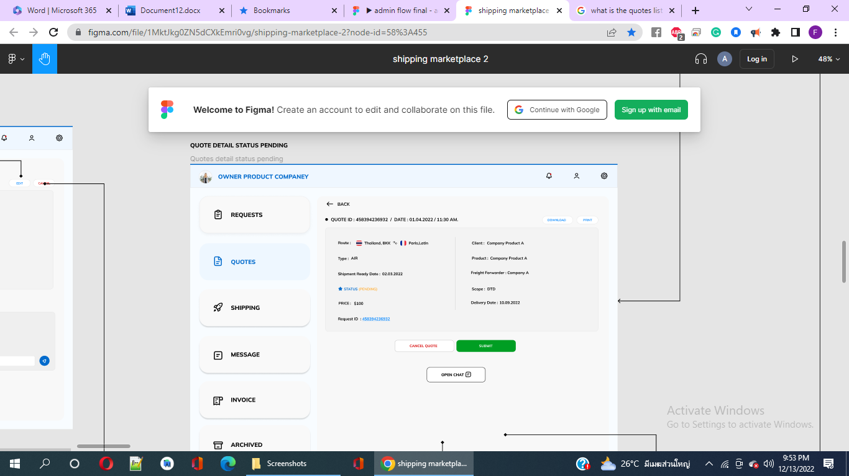

**Figure 12: quote detail status pending page**

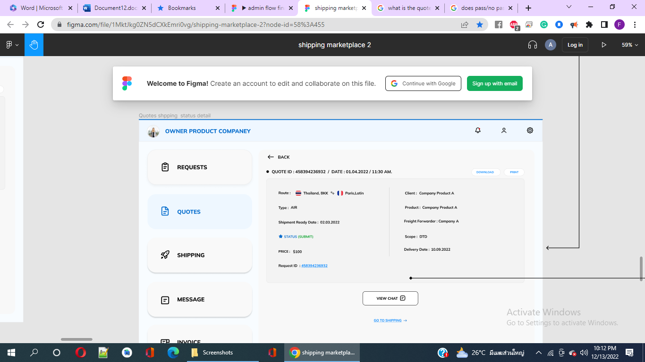

**Figure 13: Quotes shipping status detail**

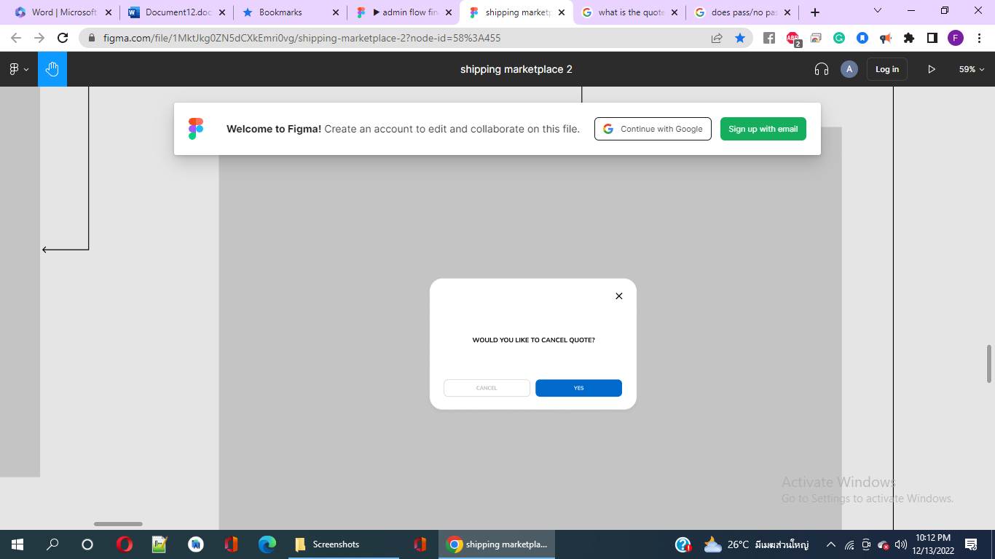

**Figure 14: Notification appears asking user if they would like to cancel quote after they clicked cancel.**

In figure 14, there’s a link named Go to Shipping, when clicked redirects to ‘**my** **shipping list**’ page as showed in figure 15. When clicked on Company A & B, it redirects to the pages named ‘**Shipping Detail Status Pending**’ (figure 16) & ‘**Shipping Detail Status Shipping Completed**’ (figure 17) respectively with the details of the companies and options as stated.

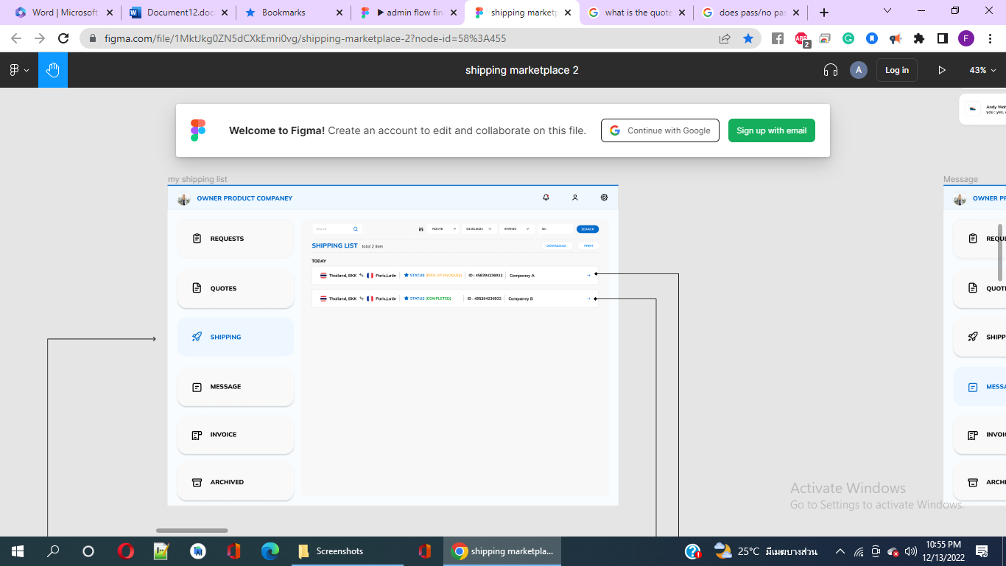

**Figure 15:** **shipping list page**

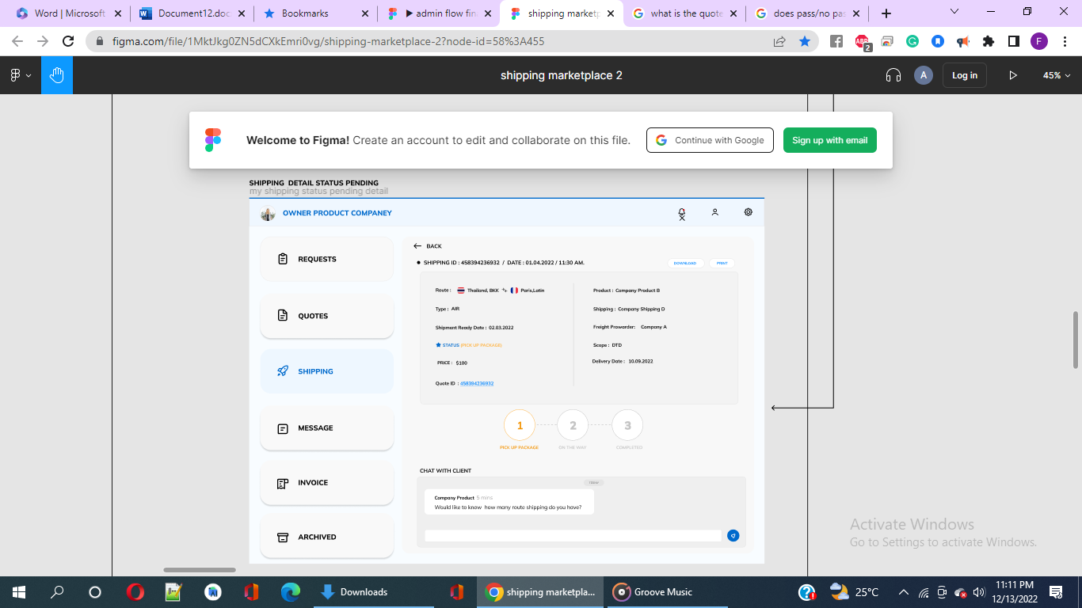

**Figure 16: Shipping Detail Status Pending**

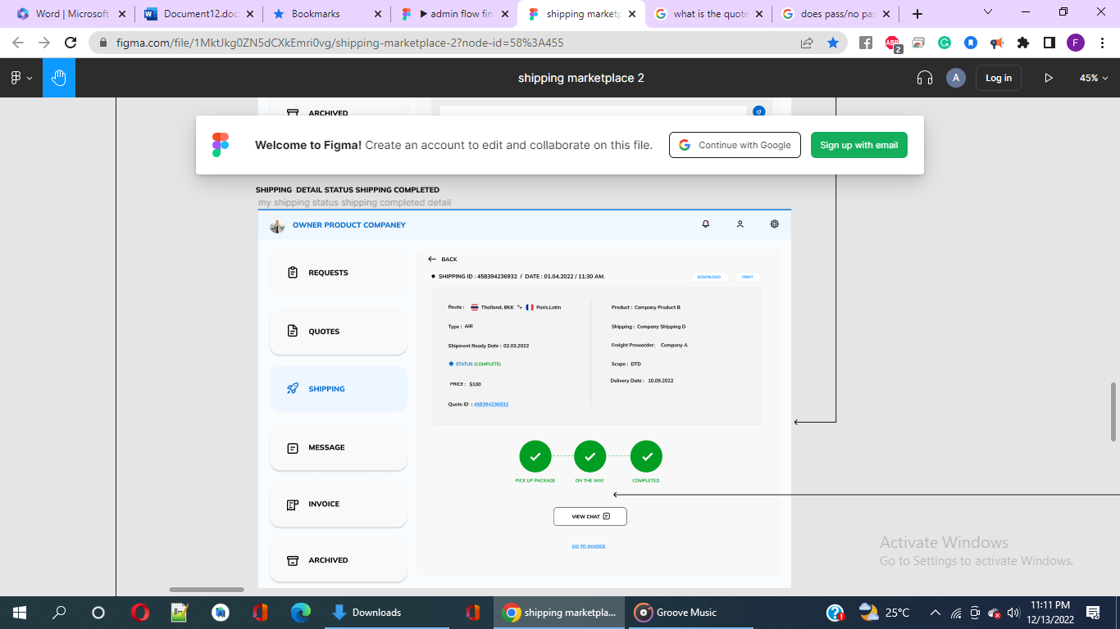

**Figure 17:** **Shipping Detail Status Shipping Completed**

In this figure above, when we click go to invoice, we are redirected to the ‘**invoice list**’ page as depicted in fig 18. When clicked on Company A with status as paid & B with pending payment, it redirects to the pages named ‘**Invoice Detail Status Pending’** (figure 19) & ‘**Invoice Paid Status Detail**’ (figure 20) respectively with the details of the companies exporting their cargos and options as stated on the pages accordingly.

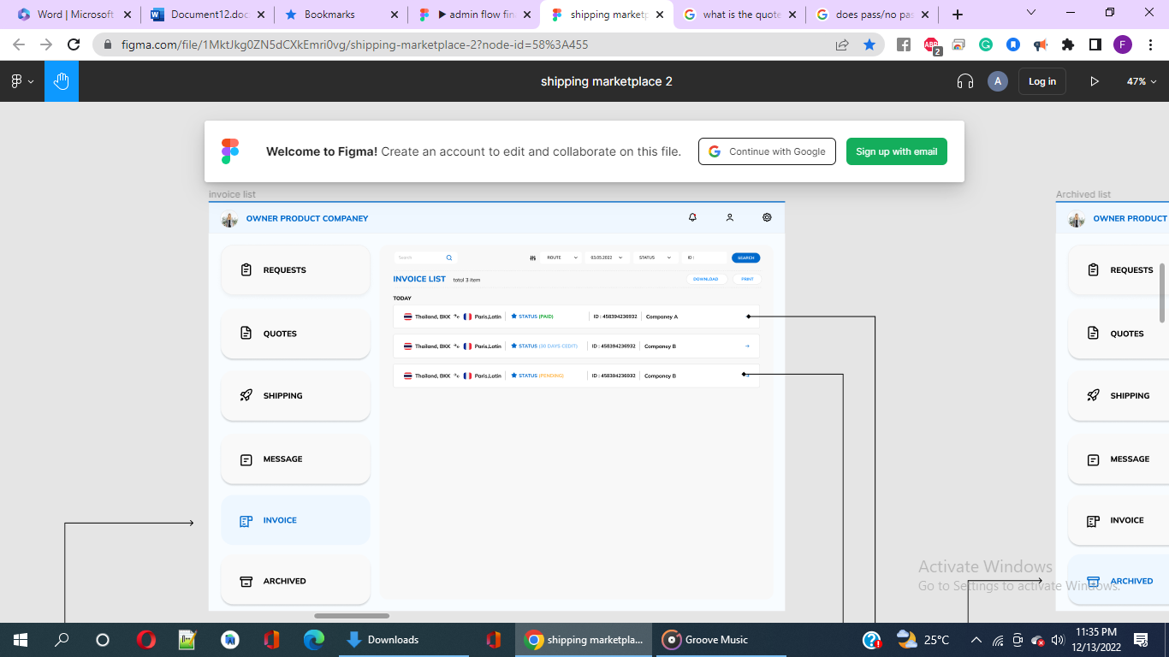

**Figure 18: ‘invoice list’ page**

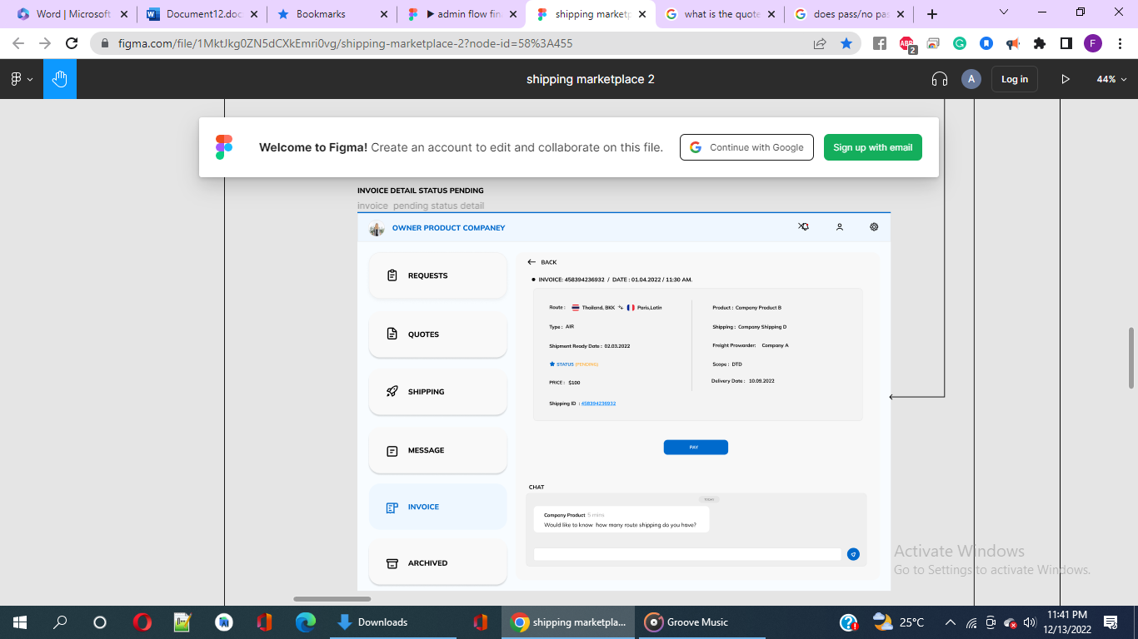

**Figure 19: Invoice Detail Status Pending**

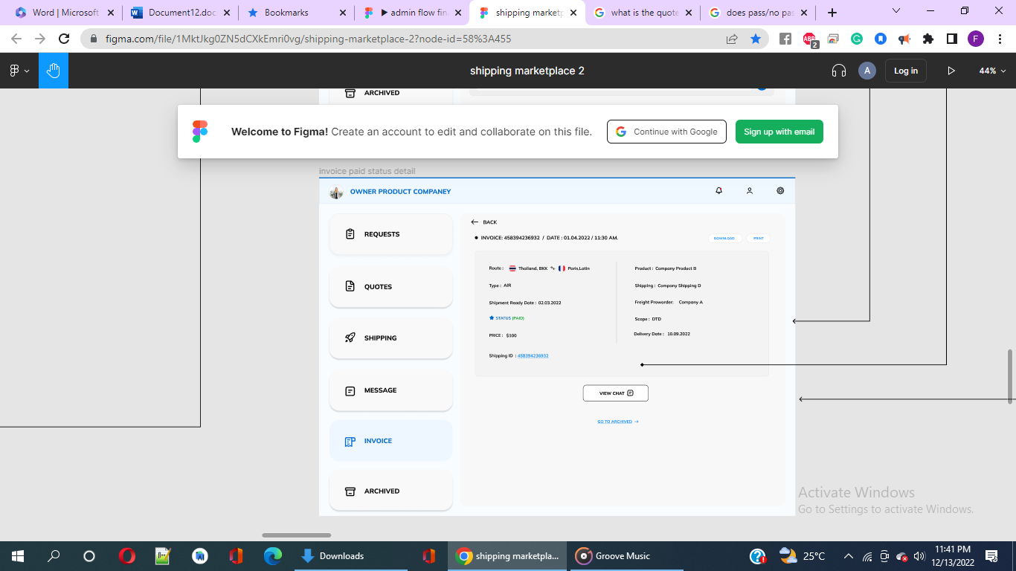

**Fig 20: Invoice Paid Status Detail**

From Fig 20, when we click on go to archive option, we are redirected to the **Archived list** as shown in figure 21. In the fig 21, when we click company A for instance, ‘**archived detail**’ page appears that shows the archived detail for the company A as showed in figure 22. Archived list usually consists of completed delivery of cargos or its cancellation.

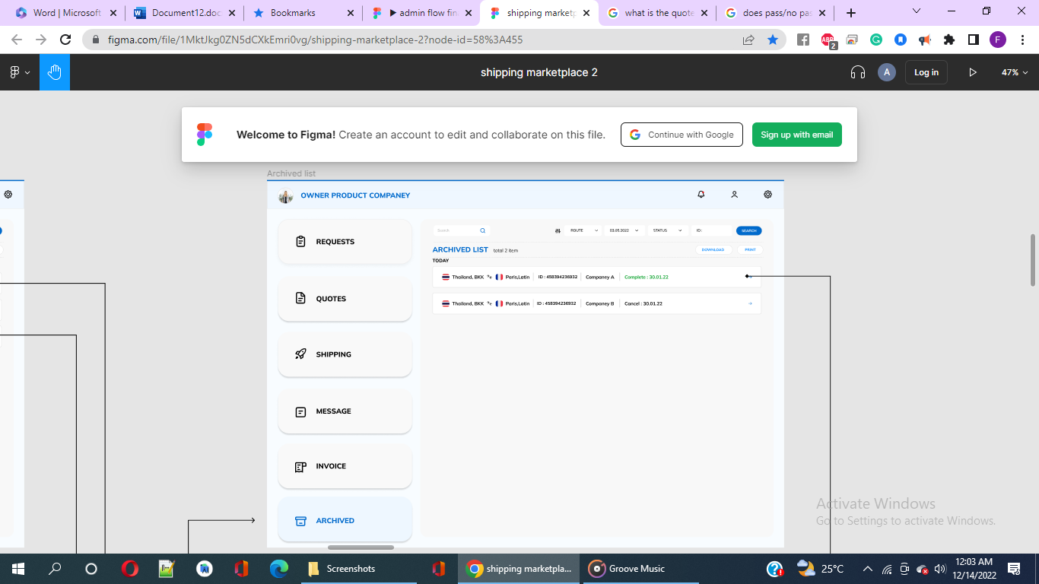

**Figure 21: Archived list**

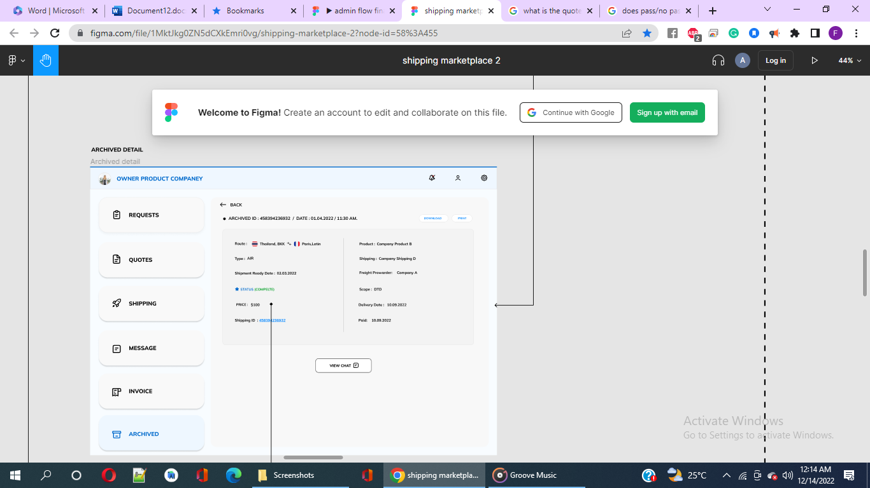

**Figure 22: ‘archived detail’ page**

In a separate area, there’s a page for **Admin** as shown in the middle of the section **under ‘owner product delivery’** below. There’s a notification for users that remind them the messages being sent to the recipient.

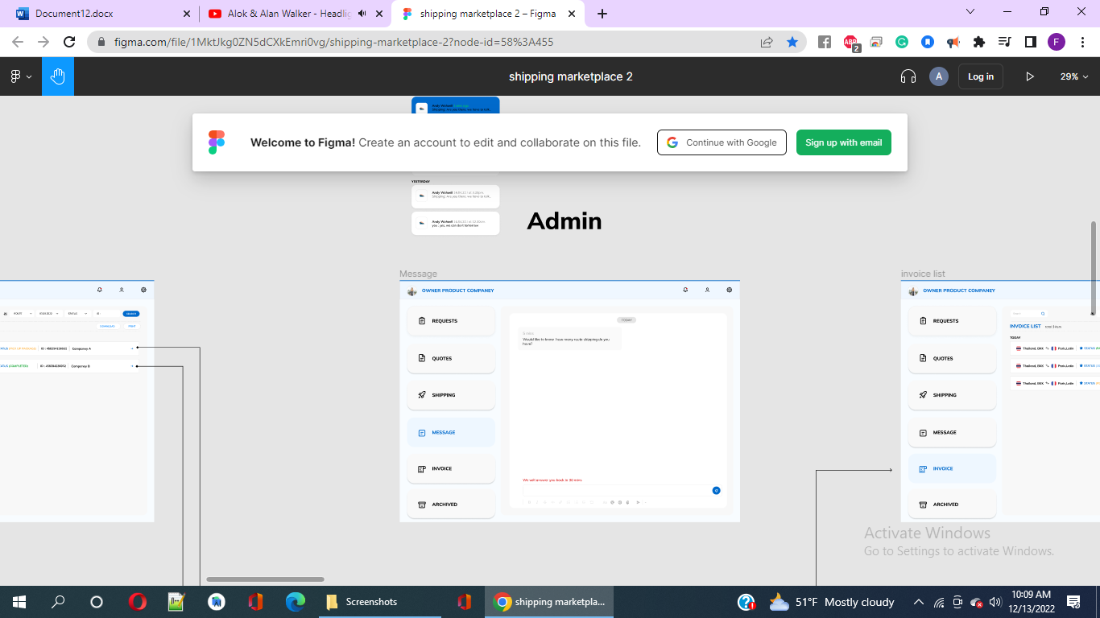

**Figure 23: Admin under ‘owner product delivery’**

We can see from the right side of the section owner product delivery consists of **invoice list, invoice detail status pending, invoice paid status detail, archived list, and archived detail** as stated in the picture below.

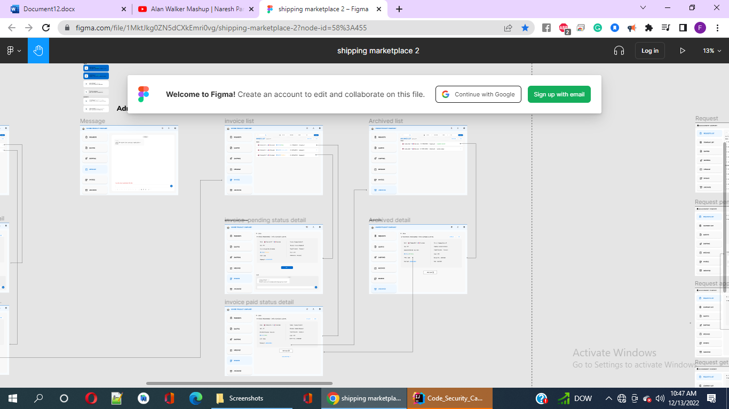

**Figure 24: The section ‘owner product delivery’ consists of invoice list, invoice detail status pending, invoice paid status detail, archived list, and archived detail.**

**ADMIN**

The Admin section area consists of a separate diagram that represents subsections of Product A, I.e., Request, Quotes, Shipping & Invoice for checking, message as a mode for communicating & account involving edit, as shown in the following two pictures accordingly.

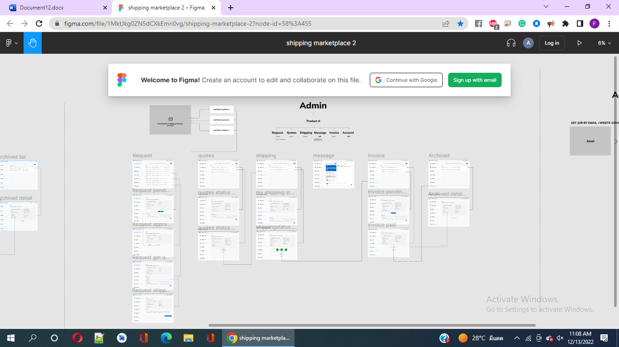**Figure 25: ’Admin’ section.**

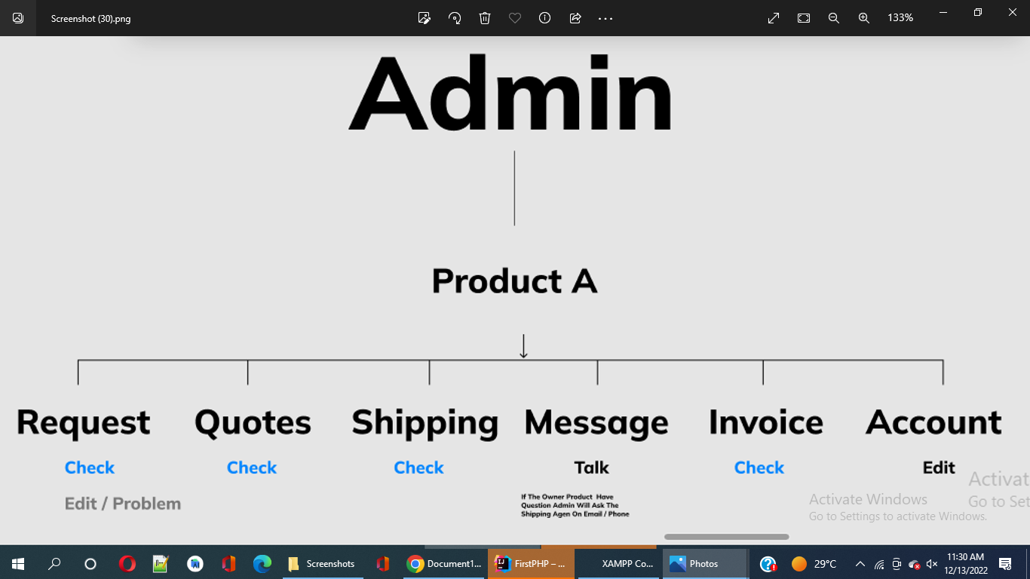**Figure 26: Subsections of Product A, I.e., Request, Quotes, Shipping & Invoice for checking, message as a mode for communicating & account involving edit.**

The following diagram shows role of a user sending email to some shipping companies e.g., Shipping Company A, Shipping Company B or Shipping Company C.

The diagram below represents the pages of‘Request checking’, which is a sub-part of Product A. The request therefore includes pages named ‘Request, Request pending detail’, ‘Request approve detail’, ‘Request Get Quotes Detail’ & ‘Request shipping company detail’.

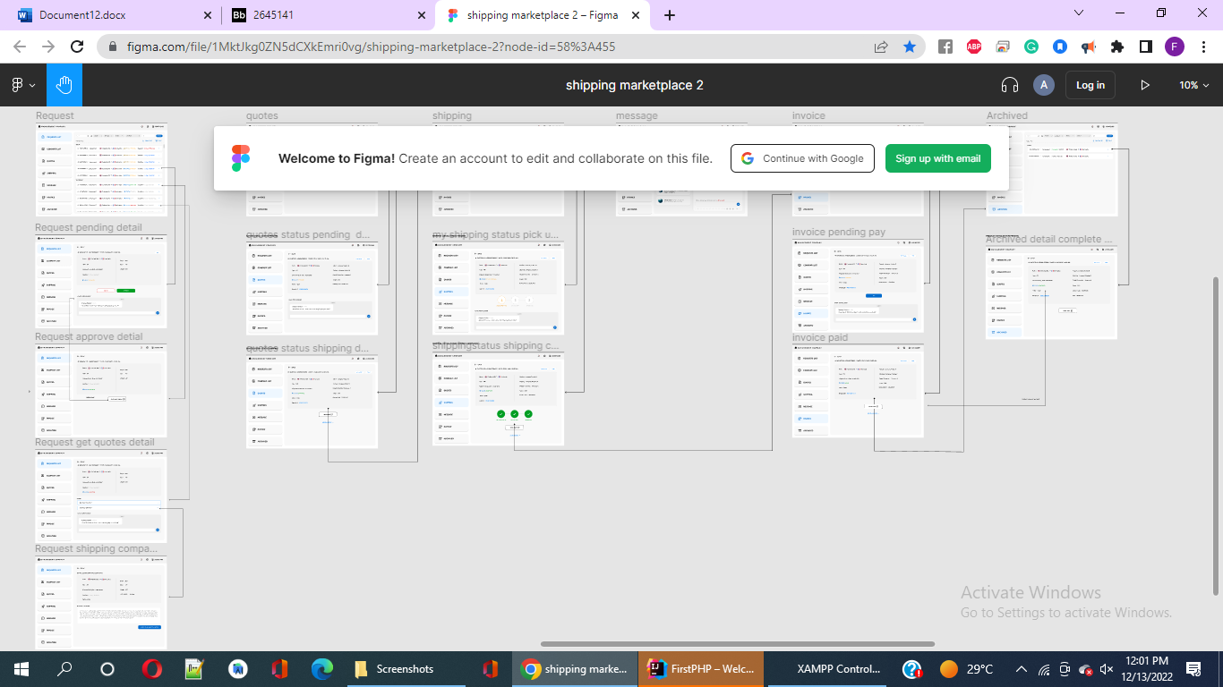

**Figure 27: The request therefore includes pages named ‘Request’, ‘Request pending detail’, ‘Request approve detail’, ‘Request Get Quotes Detail’ & ‘Request shipping company detail’.**

The diagram below represents the pages of ‘Quotes checking’, which is a sub-part of Product A. The Quotes therefore includes pages named ‘Quotes’, ‘Quotes status pending detail’ & ‘Quotes Status Shipping detail’.

Additionally presenting the pages of ‘Shipping’ for checking which is a sub-part of the Product A. The Shipping therefore includes pages named ‘Shipping’, ‘Shipping Detail Status Pending’ & ‘Shipping Detail Status Shipping Completed’.

There’s a message page under the sub-section ‘Message’ (for communication) of Product A.

Also, there are pages of ‘Invoice checking’, which is a sub-part of Product A. The Invoice therefore includes pages named ‘Invoice’, ‘Invoice pending pay’ & ‘Invoice paid’.

The Archive sub-part composes of pages named Archive and Archived detail complete project.

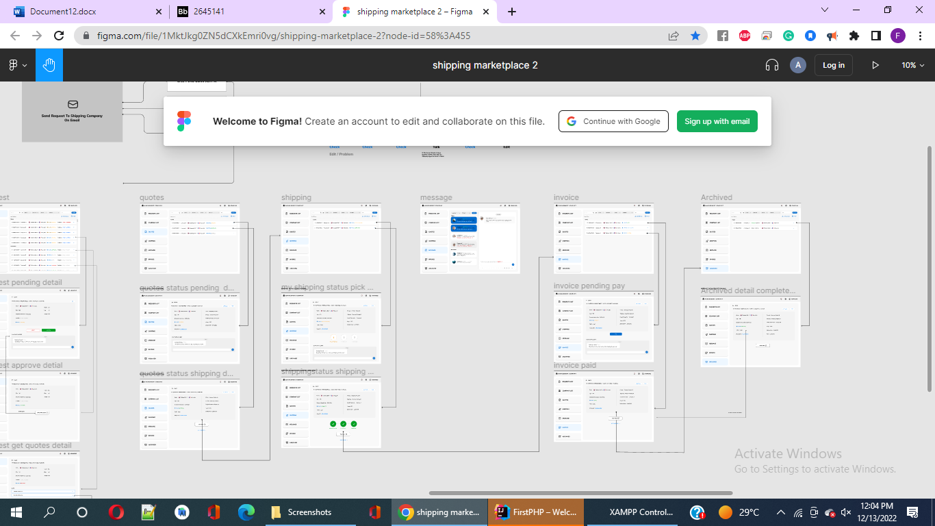

**Figure 28: Admin section presenting Request, Quote, Shipping, Message, Invoice & Archived.**

**Request** (under Admin section)

This page provides detail of the list of companies that are eligible & confirmed for exporting cargos from Thailand to foreign countries as showed in the following figure 29. We described its features before in “My request list” in the report initially.

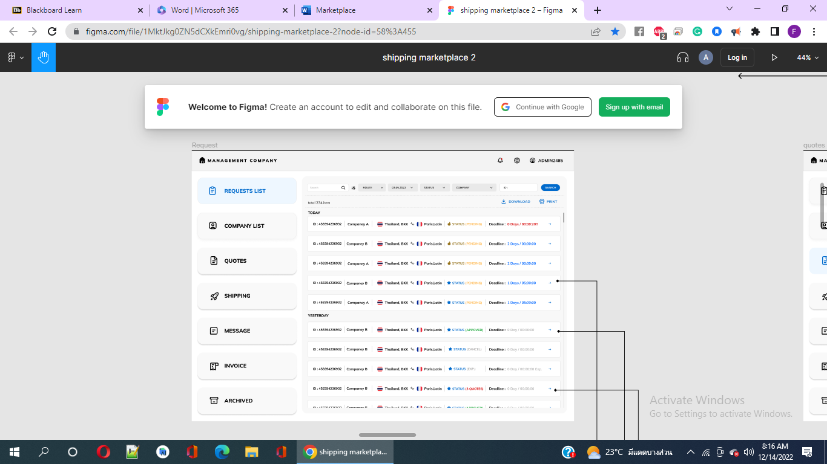

**Figure 29: Request page (under Admin section)**

E.g., when we click on the option of company B from Today with the pending status & deadline of 1 day/05:00:00, we are redirected to **‘Request pending detail’ page** as showed in Figure 30 where we see the info of the cargo is given and there’s option for ‘Approve’ & ‘Reject’. Separate chat option with the client.

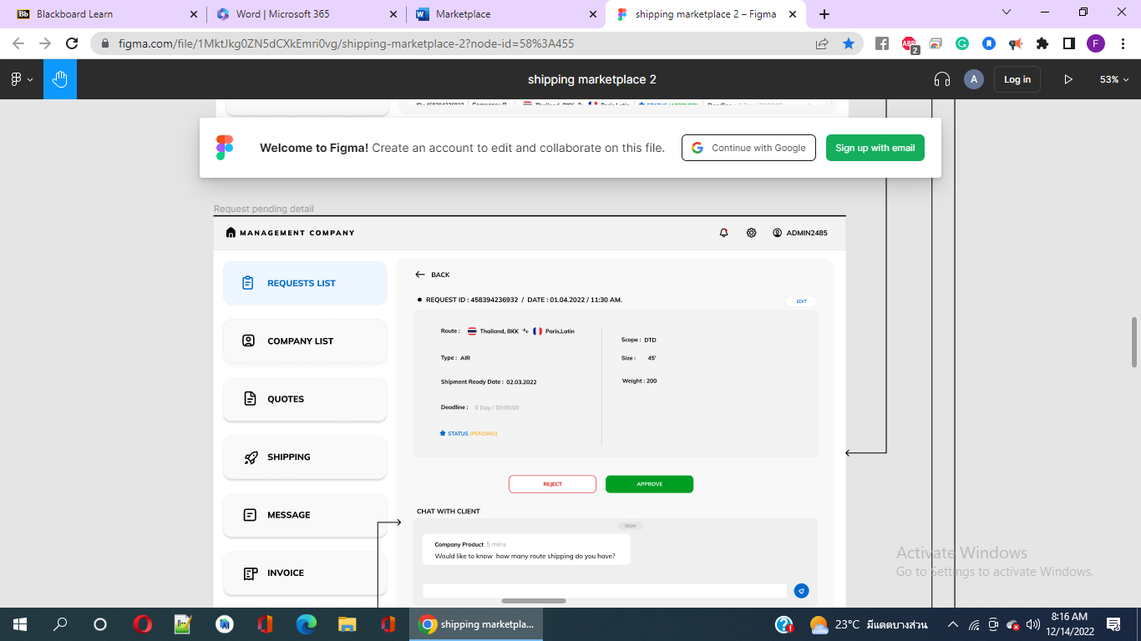

**Figure 30: ‘Request pending detail’ page**

Similarly, when from figure 29, when we click on the option of company B from Yesterday with the approved status & deadline of 0 day/00:00:00, we are redirected to **‘Request approve detail’ page** as showed in Figure 31, the info of the approved status cargo is provided & open chat area between the client and the Company Product.

**Figure 31: ‘Request approve detail’ page**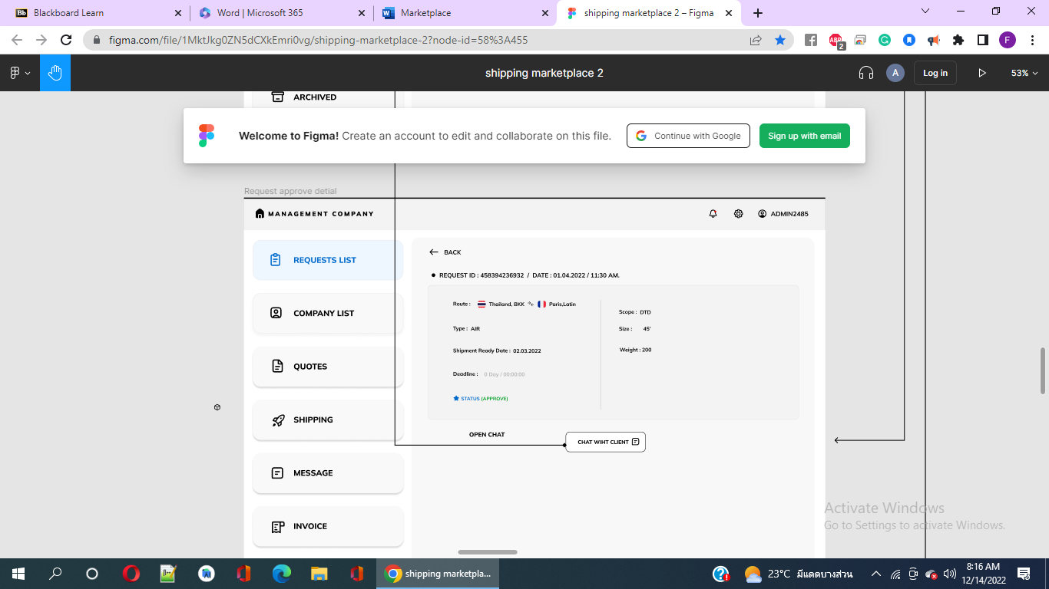

From figure 29, when we click on the option of company B from Yesterday with the 3 quotes status & deadline of 0 day/00:00:00, we are redirected to **‘Request quote detail’ page** as showed in Figure 32, the info of the approved status cargo is provided, open chat area with client and quote under which Shipping Company A & B tabs showed. When we click on the Shipping Company B, we are redirected to the page **‘request shipping company detail’** that provides the following details of Detail Quote Shipping Company B in figure 33 and an option to send message to Shipping.

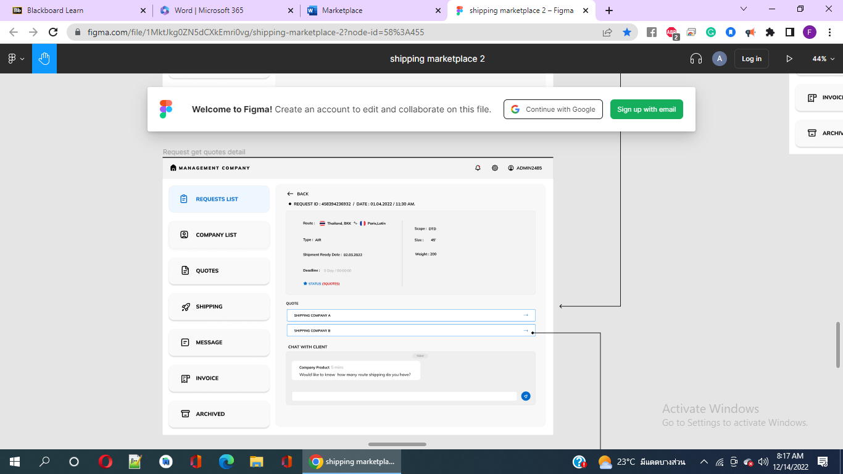

**Figure 32: ‘Request quote detail’ page**

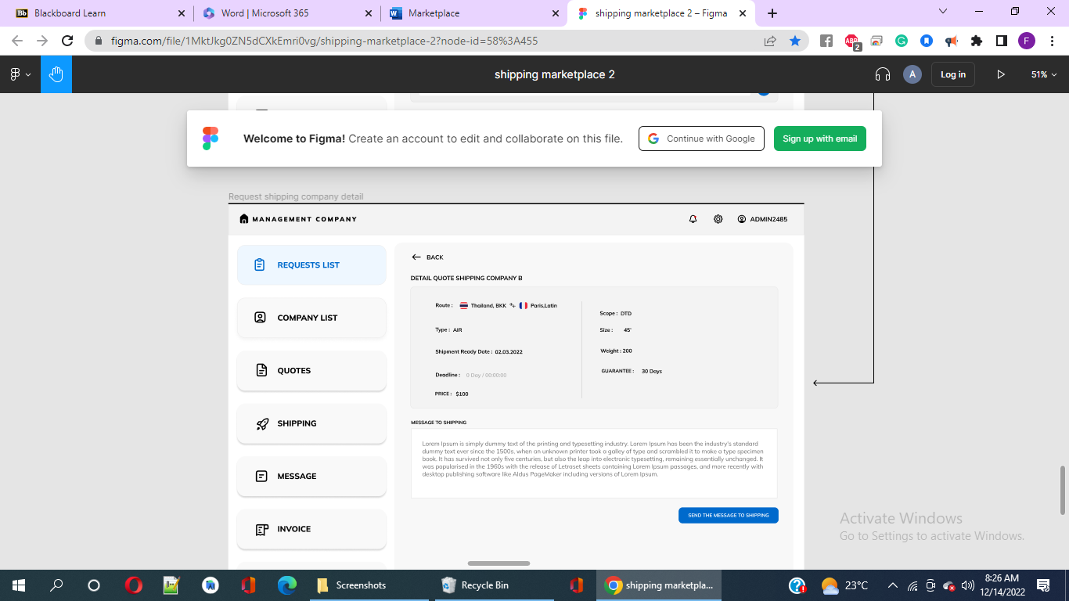

**Figure 33: page ‘request shipping company detail’**

**Quotes**

Here we see three items listed (in figure 34). Clicking on company A redirects to the page named ‘Quotes status pending detail’ (in figure 35) & clicking on company C redirects to the page named ‘Quotes status shipping detail’ (in figure 36). From figure 36, there’s option called ‘Go to Shipping’ when clicked redirects to ‘Shipping’ named page as showed in figure 37 with 2 items as of ‘Today’.

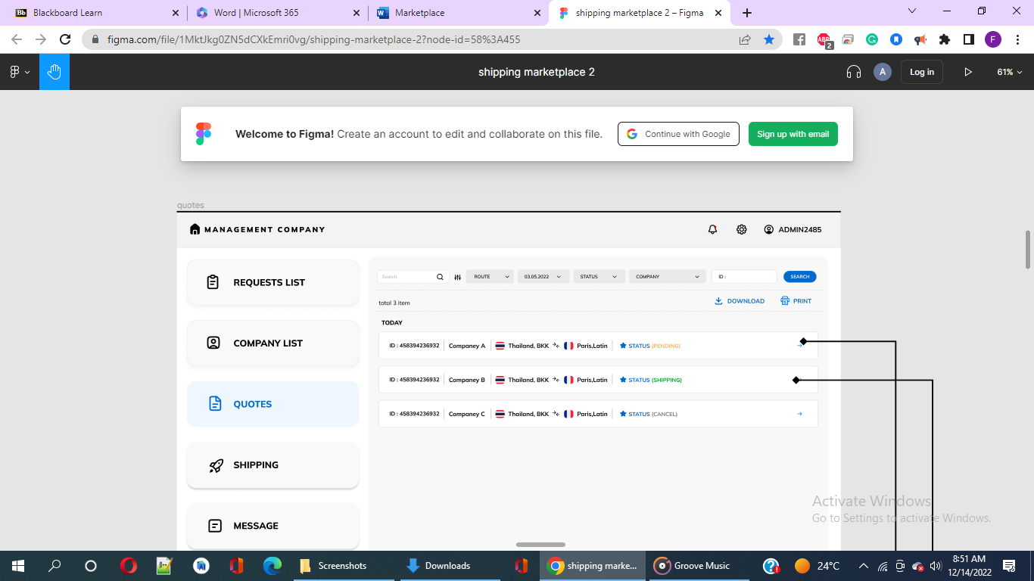

**Figure 34: page named ‘Quotes’**

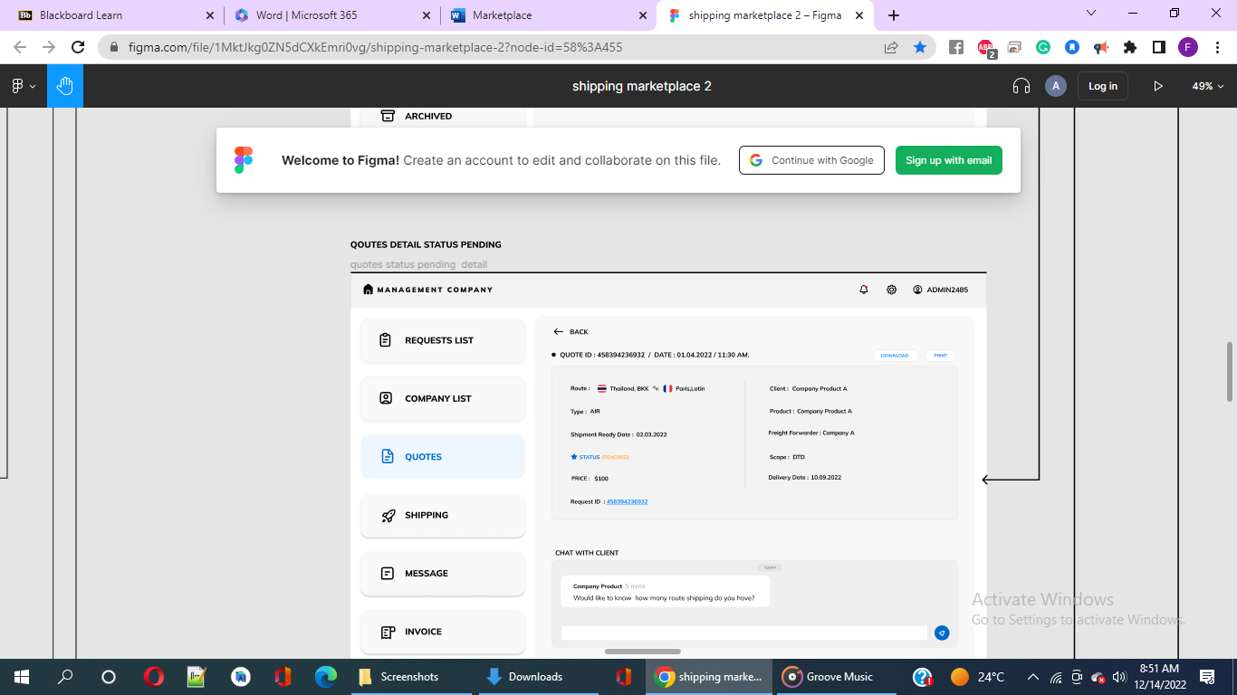

**Figure 35: ‘Quotes status pending detail’**

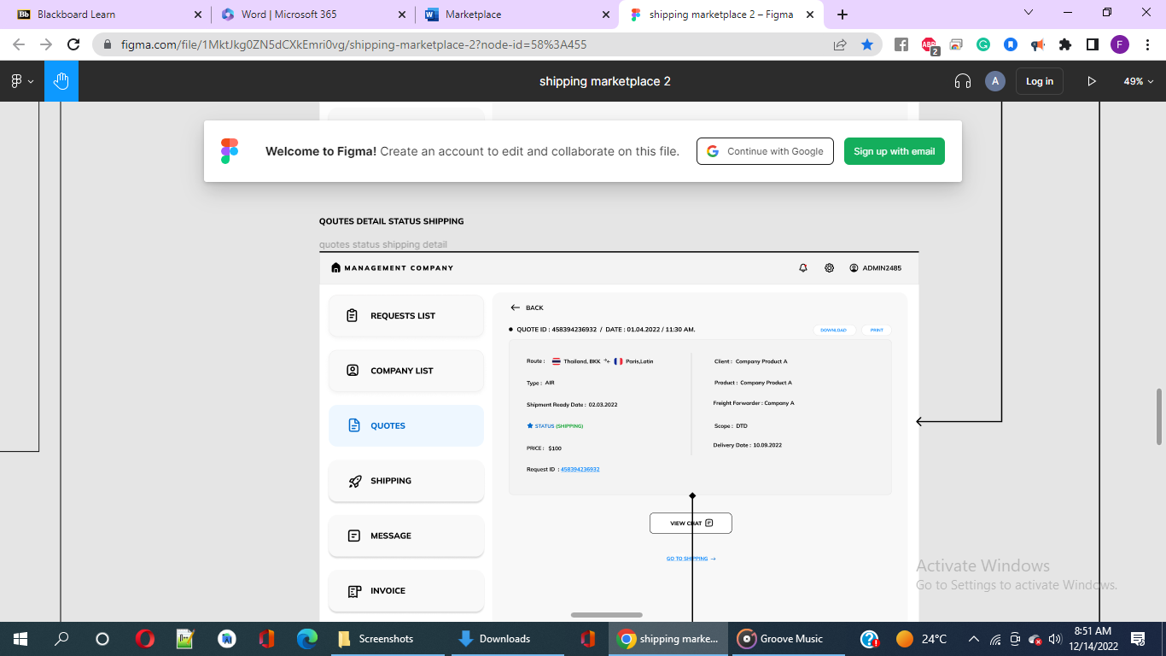

**Figure 36: page named ‘Quotes status shipping detail’**

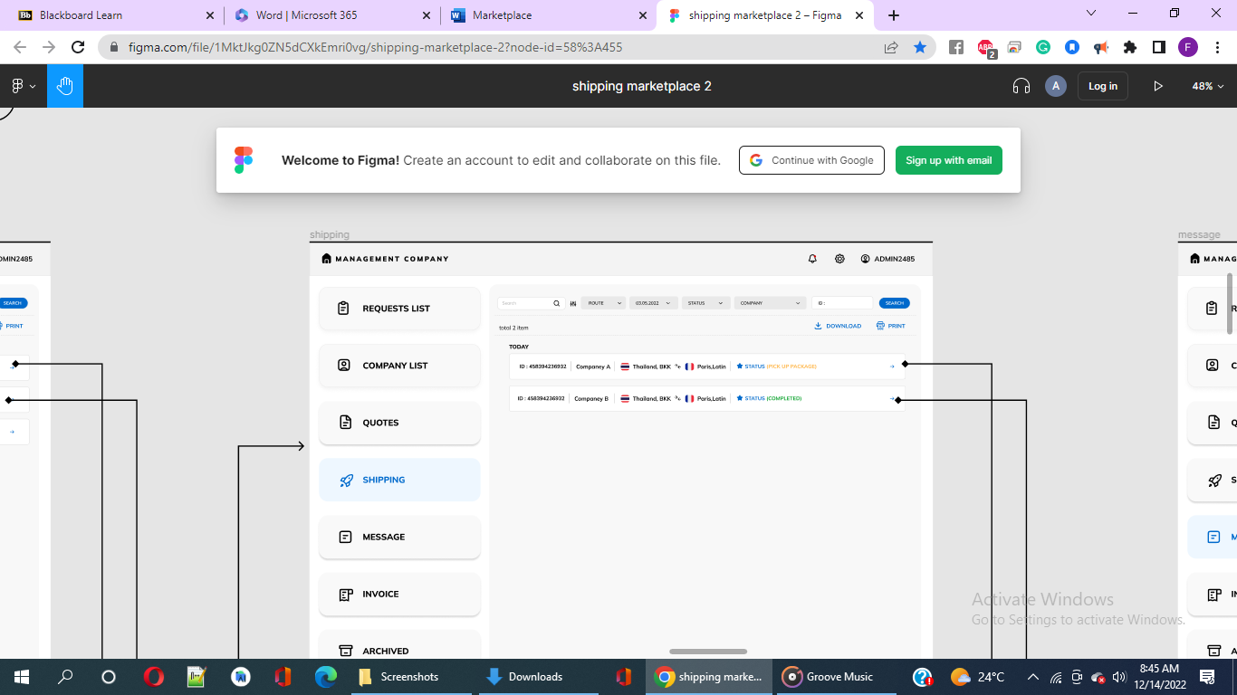

**Figure 37: ‘Shipping’ named page**

From the Shipping page, clicking on company A redirects to the page named **‘Shipping status pickup package detail’** (in figure 38 shows pickup package, completed & completed in green indicating shipping completed) & clicking on company B redirects to the page named ‘Shipping status shipping completed detail’ (in figure 39).

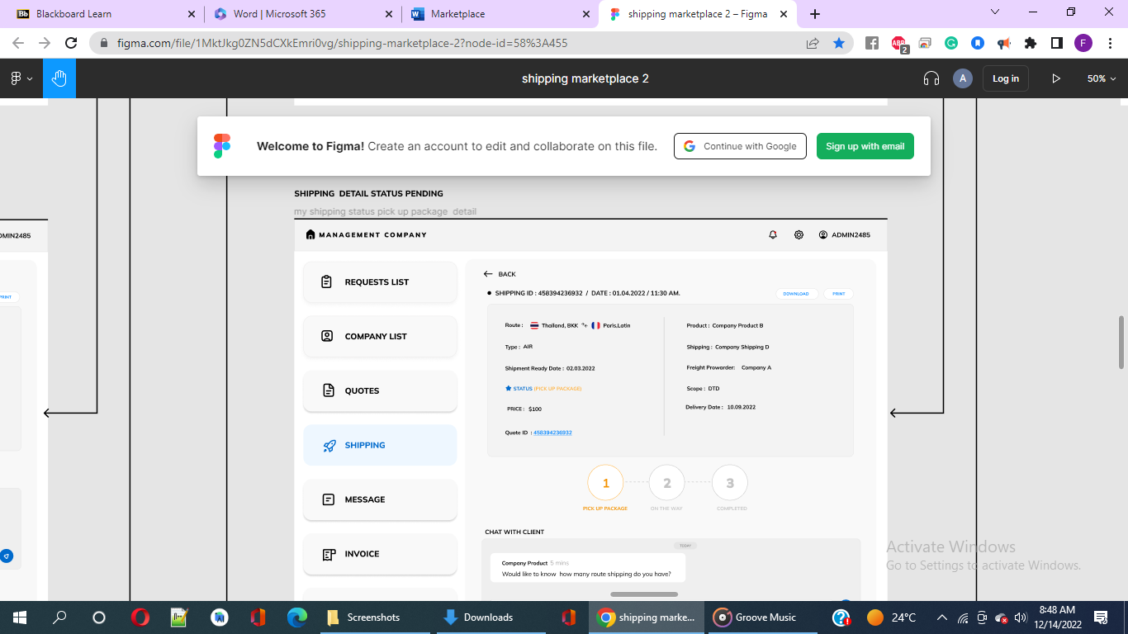

**Figure 38: page named ‘Shipping status pickup package detail’**

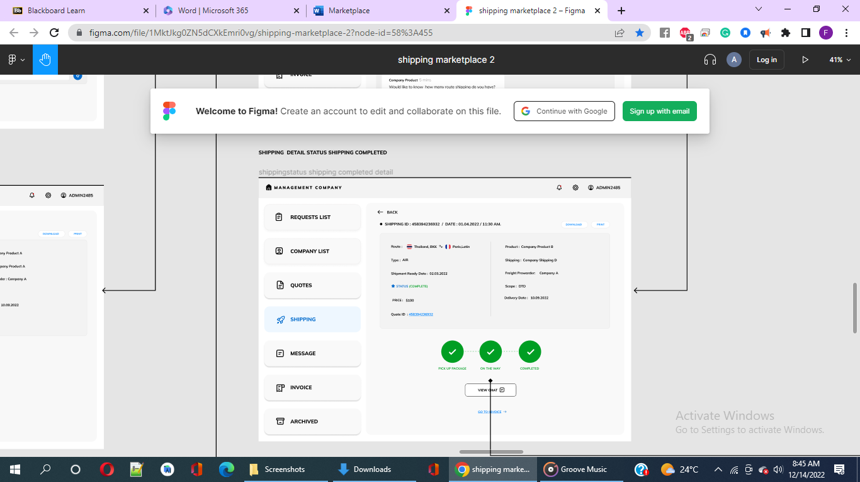

**Figure 39: page named ‘Shipping status shipping completed detail’**

From fig 39 we click on ‘invoice’ that redirects to the ‘invoice’ page (in fig 40) with three items listed. When we click the first item i.e. Company A, we are redirected to the ‘invoice pending pay’ named page, where the details for the invoice ID is along with ‘pay’ tab and open chat with client as showed in fig 41.

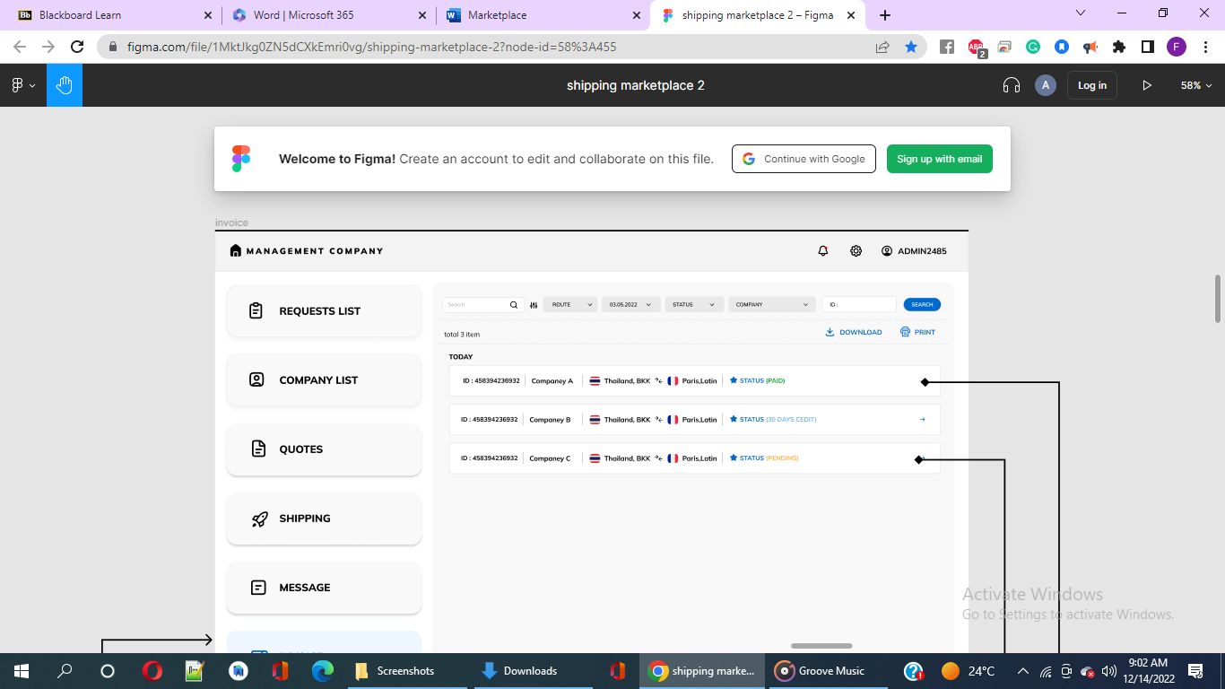

**Fig 40: ‘invoice’ page**

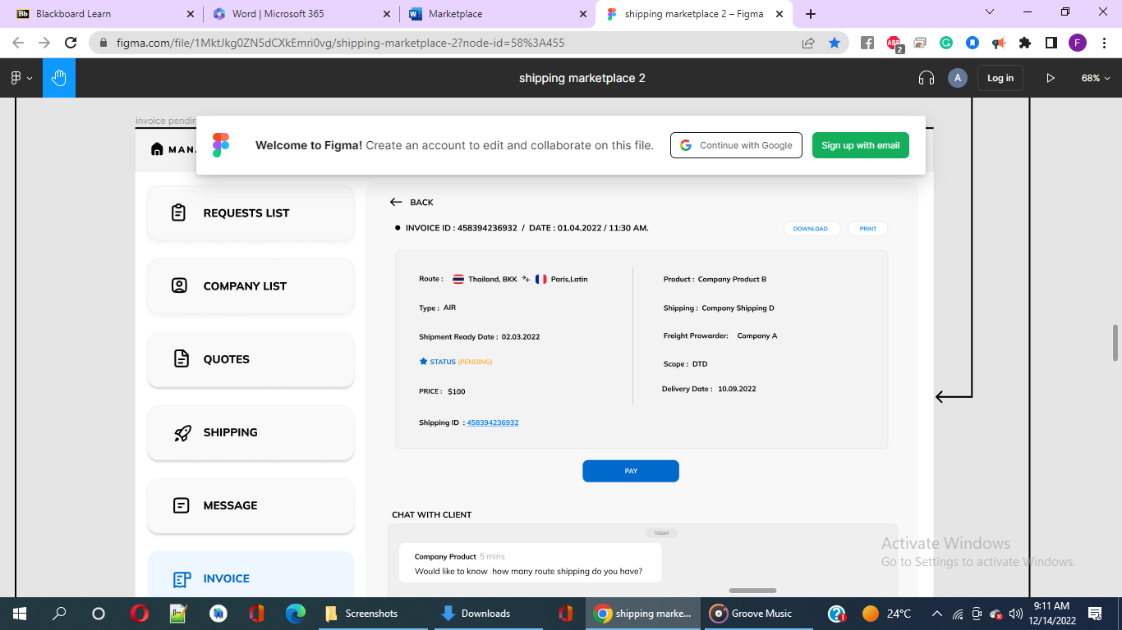

**Fig 41: ‘invoice pending pay’ named page**

When clicked on ‘pay’ in blue colour, users are redirected to ‘invoice paid’ page as showed in fig 42, when we click the ‘go to archive’ option, we are taken to the ‘Archived’ page that presents 2 items i.e., Company A & B as showed in Fig 43.

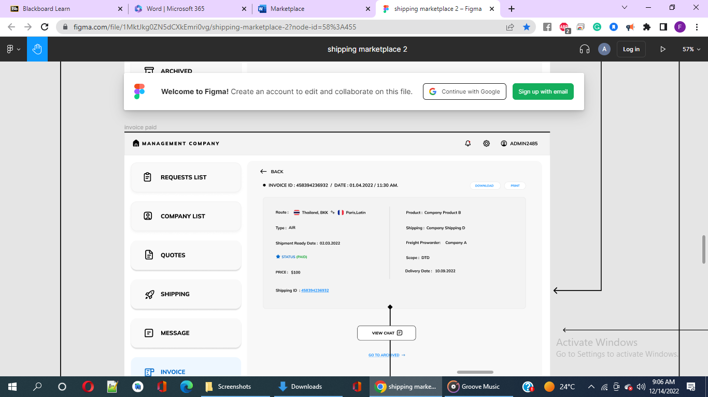

**Fig 42: ‘invoice paid’ page**

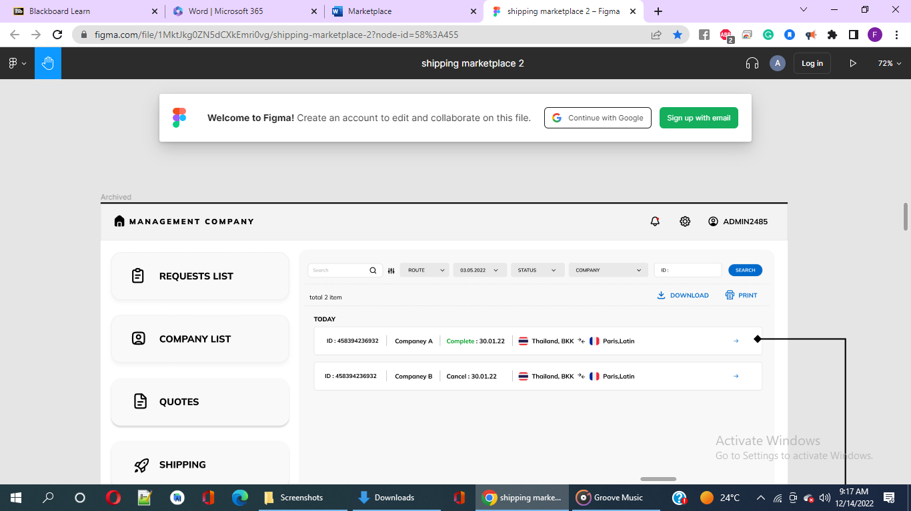

**Fig 43:** ‘**Archived’ page**

From Fig 43 of Archived page, after clicking Company A item, we are redirected to ‘Archived detail complete project’ page that is showed in Fig 44.

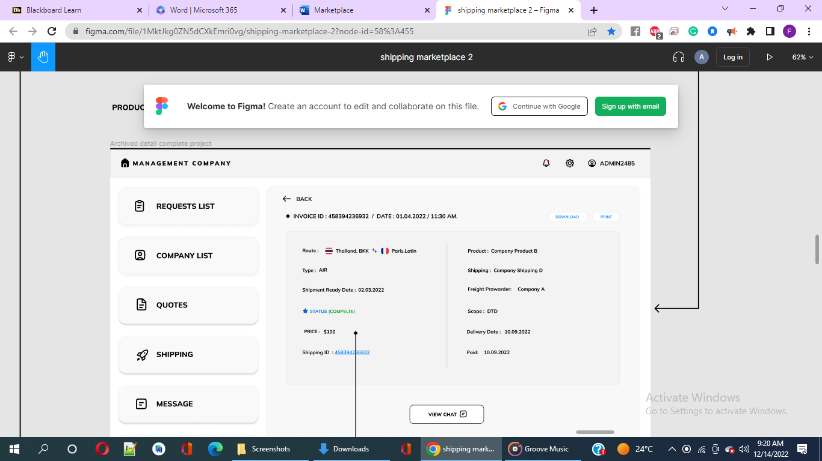

**Fig 44: Archived page**

Finally, the figure 45 below shows how the message interface between the Company Product and the clients looks like.

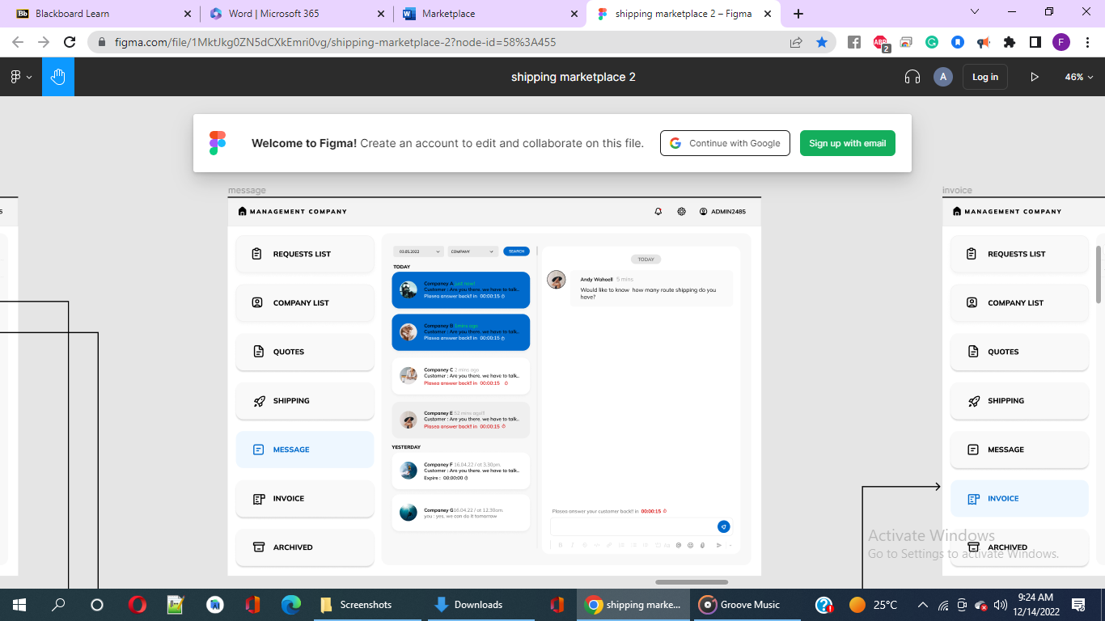

**Fig 45: Message interface**

**Agent Shipping Company**

This section is for employing staff by enabling sending of email for resume submission on the website where the job vacancy is posted. After submission, the website creates quote that the admin would be able to observe and receive.

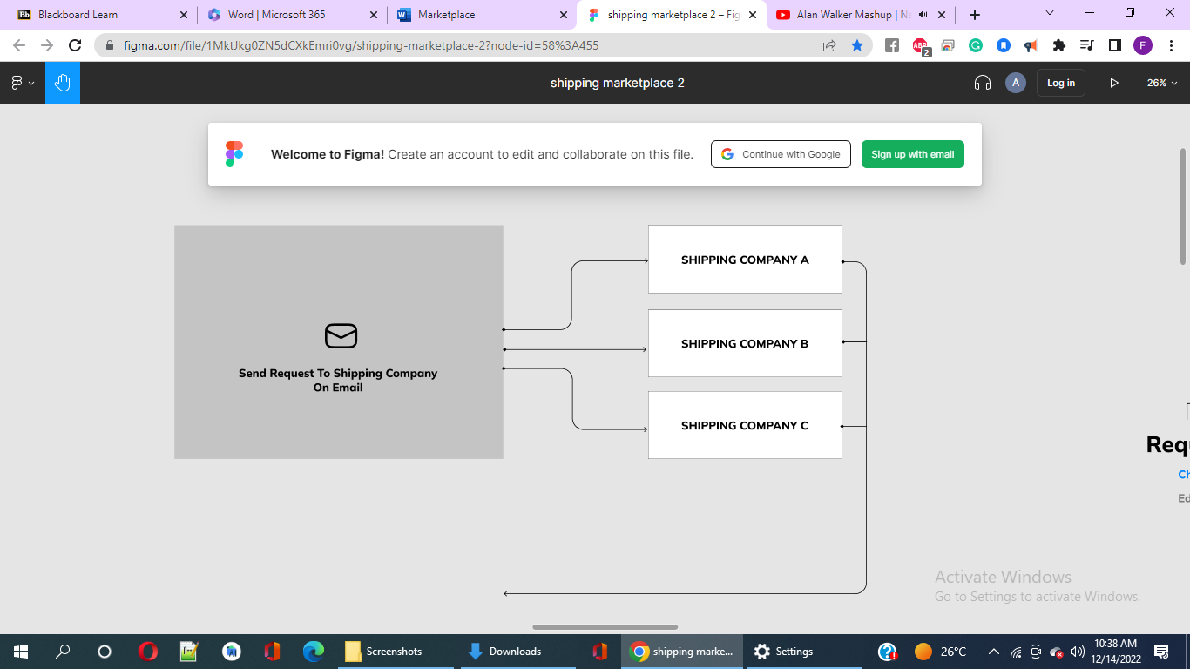

**Fig 46: Shows employment of staff by enabling sending of email for resume submission on the website where the job vacancy is posted.**

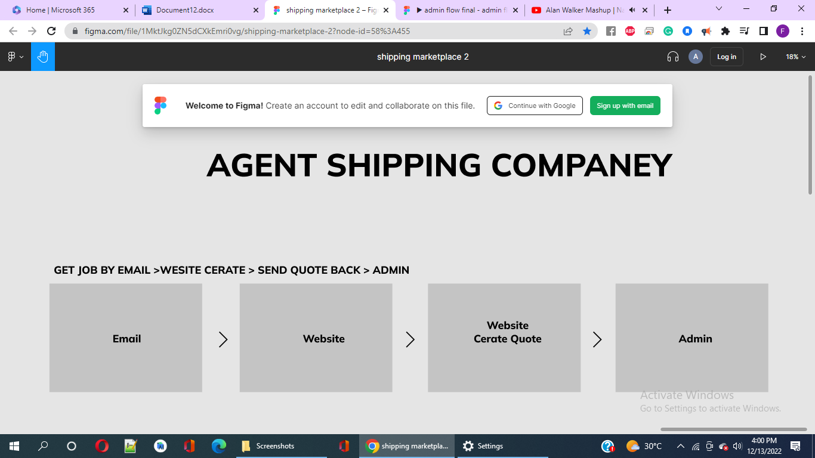

**Fig 46: This part therefore consists of email, website, website create quote & admin.**